APP Development

Layouts:
vlayout weight (space covered by views left in layout)
layout sum
layout gravity (center,left,right etc)
nested linear layout

Major Noticed:
when we move big view in constraint layout, small view attached to it also moves.
But when we attach small view at top of big view, it will only move according to
size of text of big view
Scale Type for images, image view
Drawable -> New -> vector asset -> clip art

Sources:

flaticon for avatars, dribble, uplabs

start for left, end for right in constraints

begin for left, end for right in guidelines

We use guidlines instead of margins in constraint layouts

Ctrl+Click to remove constraint

We can make splash screen using thread class and first we use getSupportActionbar().hide()
and then we can make run function inside it we use sleep function in try block, then in
catch block we catch exceptin and in finally block we start our actual main activity
after creating thread object. we start the activity

To make back arrow on activity, we use supportactionbar with setDisplayOnHomeEnabled function
value true and setTitle for title. Similarly, we use onSupportNavigation function with
backpressed function called in it for backKey enabled

Explicit Intent:
These are used to send data from one activity to other, when we actually know about
our destination source.

Implicit Intent:

Intents are used to call services/activities as one category and broadcast receivers
like low battery notification, power saving mod, low your brightness, change network from
wifi to data.

PackageManager:

Package manager is just use to handle intents and it checks for apps that are
suitable for intents

intent.setAction(Action_Send)// to share data with other apps
intent.setType("text/plain") // set type of text

RecyclerView and Adapter:

We use recyclerview to make grids and lists. Adapter can be used to place data on views
online via databases. It is actually middle man.

SnackBar:

Snackbar is like toast but it has button in it, binding is duplicate of linking
frontend with backend
Actually, for every layout file , binding class is generated (Pascal Case)

Benefits of Binding:
It has properties for views in binding class. It will be type safety, like property generated
will match with exact view. No null reference error as it will have only defined properties
for each view we are using. It generates compile time error

The inflate() method
returns an instance of the binding class
that contains references to all the views defined in the layout file.

Table is root. Layout is our room and decorations are our views
Just like the table or stand in our party decoration example,
Showroom is root and views are cars inside it and place holding show room is like layout.
binding.root is the view that holds all the other views defined in the layout file,
and it serves as the starting point for accessing and manipulating the views in the layout file.
Use unbind() to avoid memory leaks.

In addition to memory leaks, failing to unbind View Binding instances can also cause issues with configuration changes.
For example, if your app is in landscape mode and the user rotates the device to portrait mode, the system will destroy and recreate the activity to apply the new configuration.
If you haven't properly released the View Binding instance in onDestroy(), the new activity instance will hold a reference to the old instance's views,
which can cause unexpected behavior.

registerForActivityResult and ActivityResultLauncher and ActivityResultContracts:
In summary, registerForActivityResult() is used to register an ActivityResultLauncher for a specific ActivityResultContract and handle the result of the activity. ActivityResultContracts.RequestPermission() and
ActivityResultContracts.RequestMultiplePermissions() are ActivityResultContracts used to request permissions. The MODE_PRIVATE is a flag that specifies the access level of the shared preferences file. ActivityResultLauncher gets map<string,Boolean> of permissions along with their status. Lambda expression used to take actions on received result of permission
- Private val requestPermissions : ActivityResultLauncher<String> = registerForActivityResult(ActivityResultContracts.RequestPermission()) { isGranted : Boolean -> do something}

Shared Preferences
Some common use cases for SharedPreferences include:
- Storing user preferences and settings such as language preference, theme preference, and sound preferences.
- Storing user authentication tokens to enable automatic login when the user restarts the app.
- Storing user preferences for offline behavior, such as whether the app should download data in the background or only when connected to Wi-Fi.
- Actually, permissions data is also stored in preferences files. So, it’s used to access whether permissions were asked or not.
- In the code snippet you provided, the prefs object is an instance of the SharedPreferences class, which is used to retrieve and store data from the shared preferences file.
- In order to modify the data in the preferences file, we need to get an instance of the SharedPreferences.Editor class, which is returned by calling the edit() method on the SharedPreferences object. Once we have an instance of the SharedPreferences.Editor class, we can use its methods, such as putBoolean(), to modify the data in the preferences file.
- In the code snippet, instead of calling prefs.edit().putBoolean(KEY_PERMISSION, true).apply(), the putBoolean() method is called inside a lambda expression passed to the edit() method using the Kotlin extension function edit{}. This is a shorthand way to call edit() and apply changes to the preferences file.
- So the code prefs.edit{ putBoolean(KEY_PERMISSION,true) } is equivalent to calling prefs.edit().putBoolean(KEY_PERMISSION, true).apply(). Both ways are valid, and the choice between them is mainly a matter of style and personal preference.

Data Binding:
We can use only setContentView(R.layout.activity_main) activity_main is name of xml file. But for this we have to use findViewById function in order to access views. You can use DataBindingUtil class that used as DataBindingUtil.setContentView(this,xml_file). Here this is object of Kotlin file and in second parameter we have to give name of xml file as activity_main.
Another way is using inflating, binding = ActivityMainBinding.inflate(layoutInflater) and then using binding.root view to access top view of layout and then set it on screen using setContentView(binding.root).
Layout tag is auto included in inflate case and in other case we have to define layout tag in xml file as root view and DataBindingUtil class explicitly takes filename of xml and then do actions while inflate implicitly works means auto look up for xml file.

Fragments:

Use getSupportFragmentManager() when working with fragments in activities that extend AppCompatActivity or any other support library activity.
Use getFragmentManager() when working with fragments in activities that extend Activity or FragmentActivity.

Code:
private fun replaceFrag(fragment : Fragment) {
val trans = supportFragmentManager.beginTransaction()
trans.replace(R.id.fragment_container,fragment)
trans.commit()
}

Fragment Life Cycle:
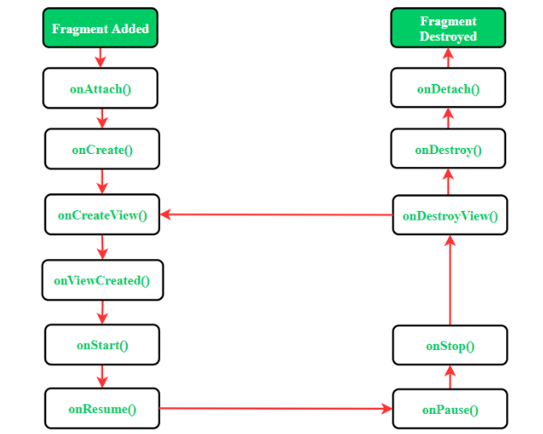

Activity Life Cycle when we open another fragment:
- F1 onpause stop
- F2 cycle till onstart
- F1 ondestroyview, destroy and detach
- F2 onresume

